Sakila Database Exercises

Exercises Each Exercise should return at least one record, according to its individual specification.

1)Select all Actors from the table.

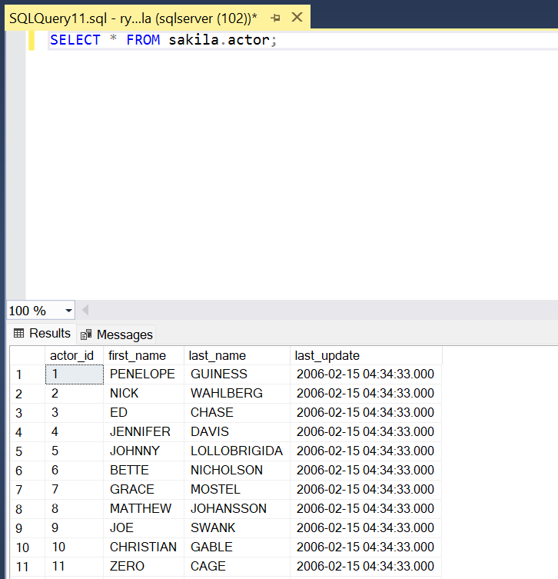

2)Find the actor with the first name “John”.

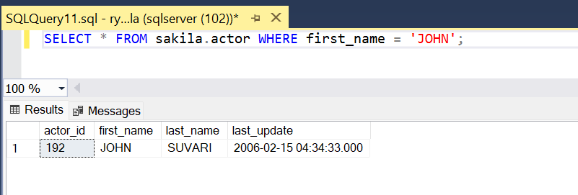

3)Find all actors with the surname “Neeson”.

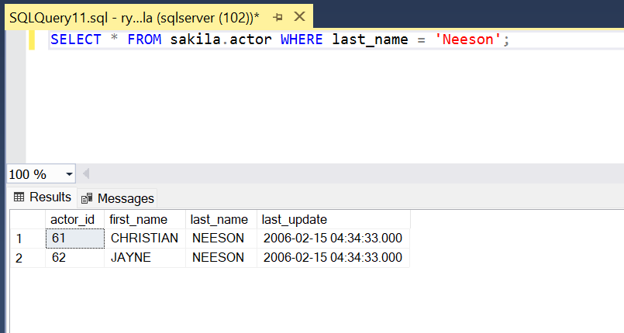

4)Find all actors with Id numbers divisible by 10.

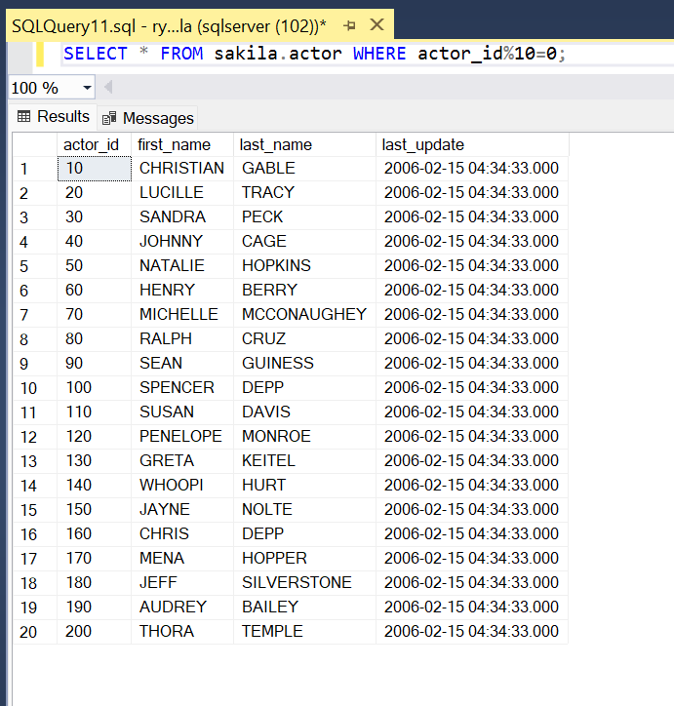

5)What is the description of the movie with ID of 100?

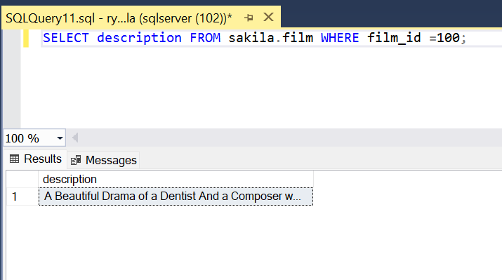

6)Find every movie with a rating of “R”.

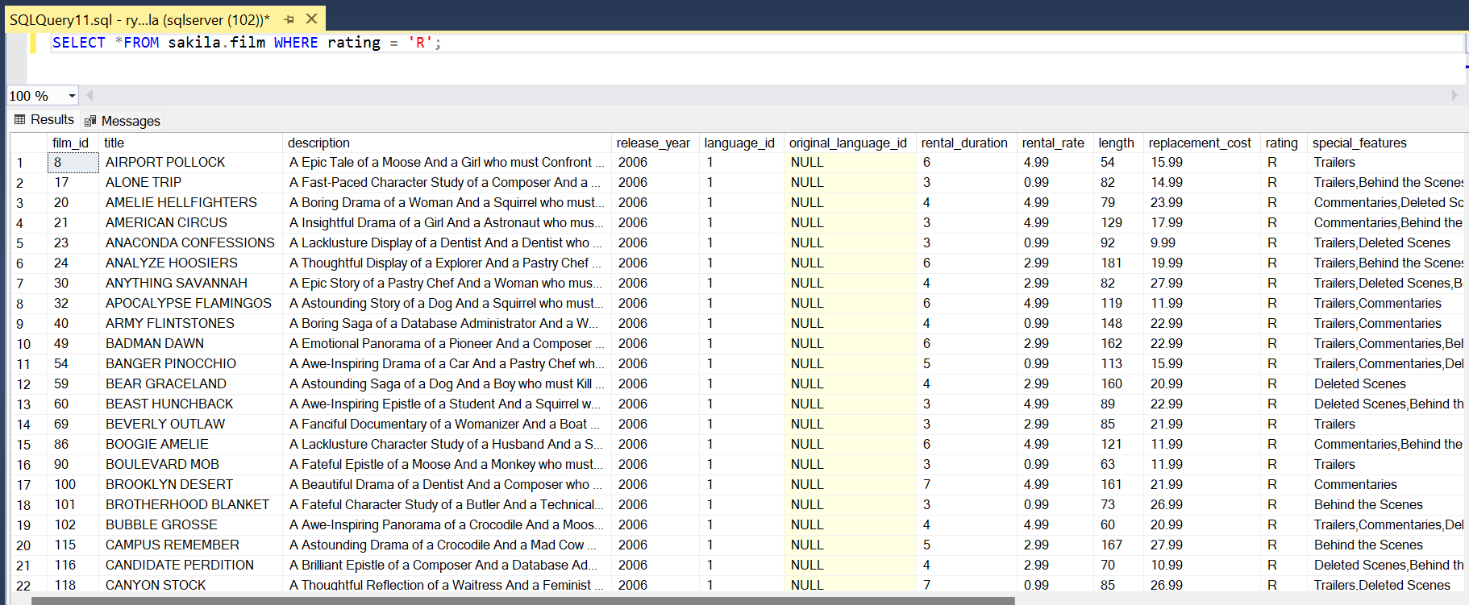

7)Find every movie except those with a rating of “R”.

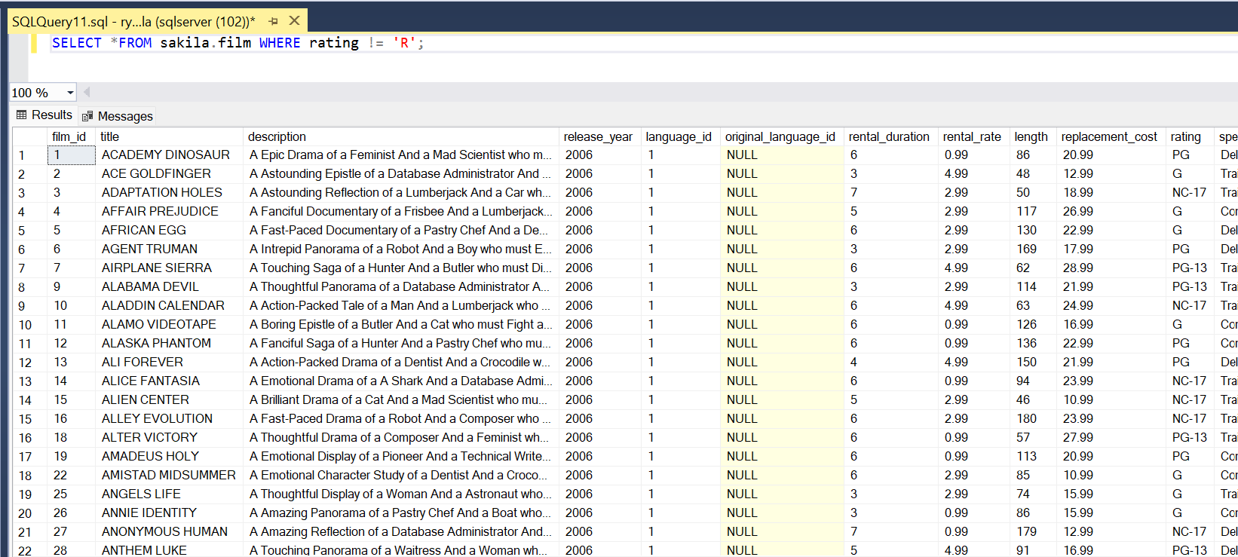

8)Find all movies with Deleted Scenes.

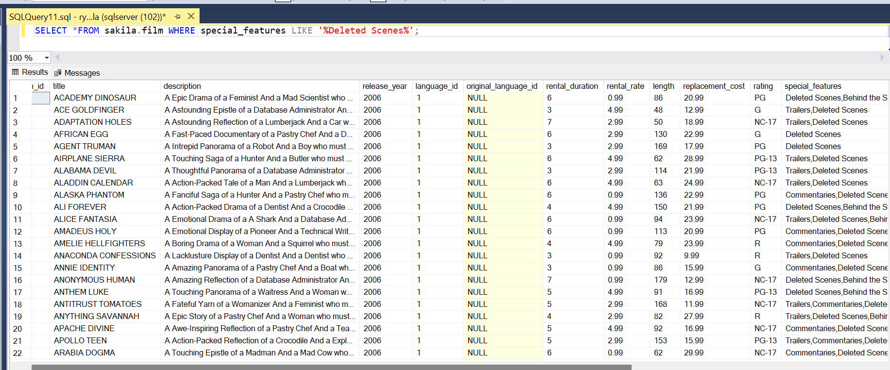

9)Which last names are not repeated?

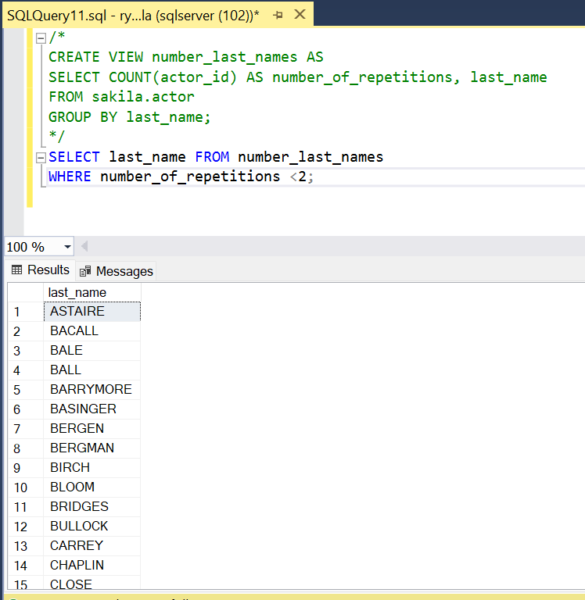

10)Which last names appear more than once?

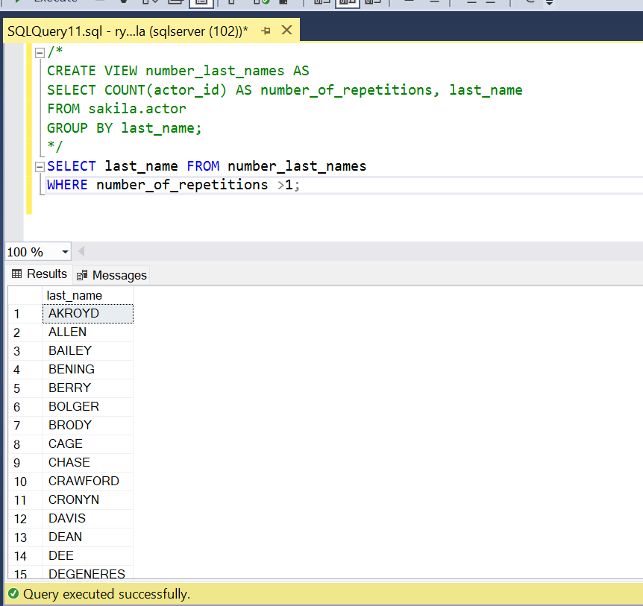

11)Which actor has appeared in the most films?

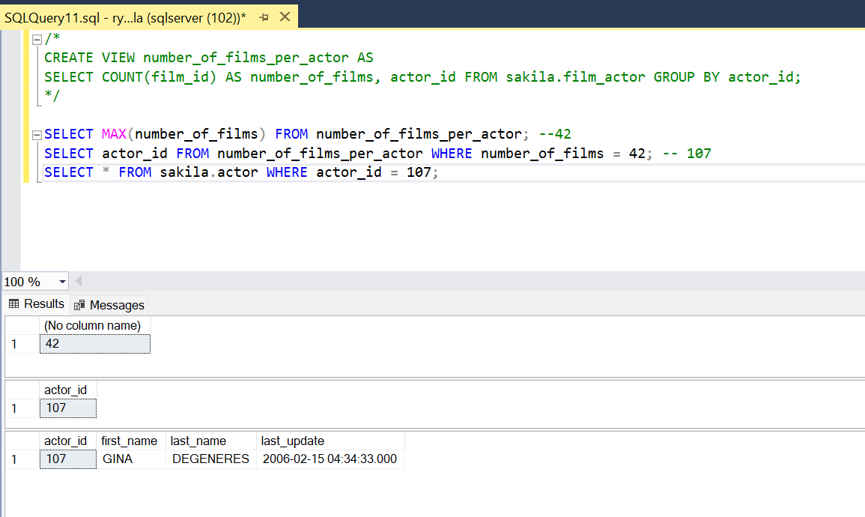

12)Is ‘Academy Dinosaur’ available for rent from Store 1?

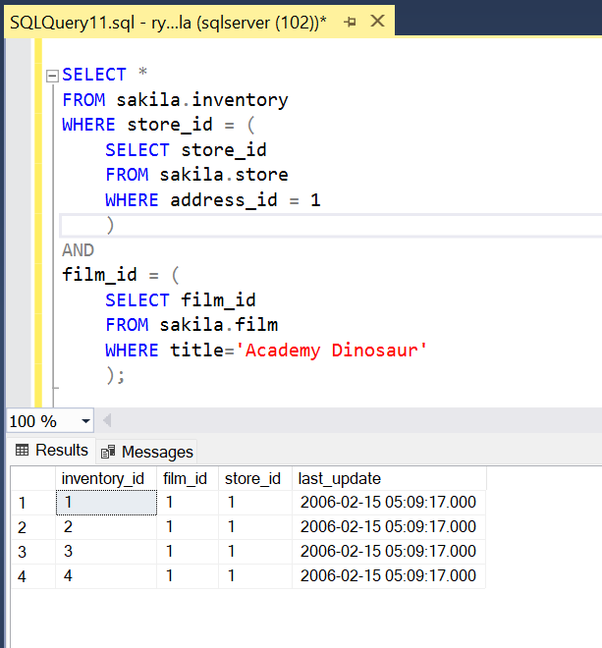

13)What is that average running time of all the films in the database?

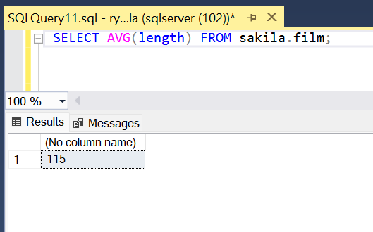

14)What is the average running time of films by category?

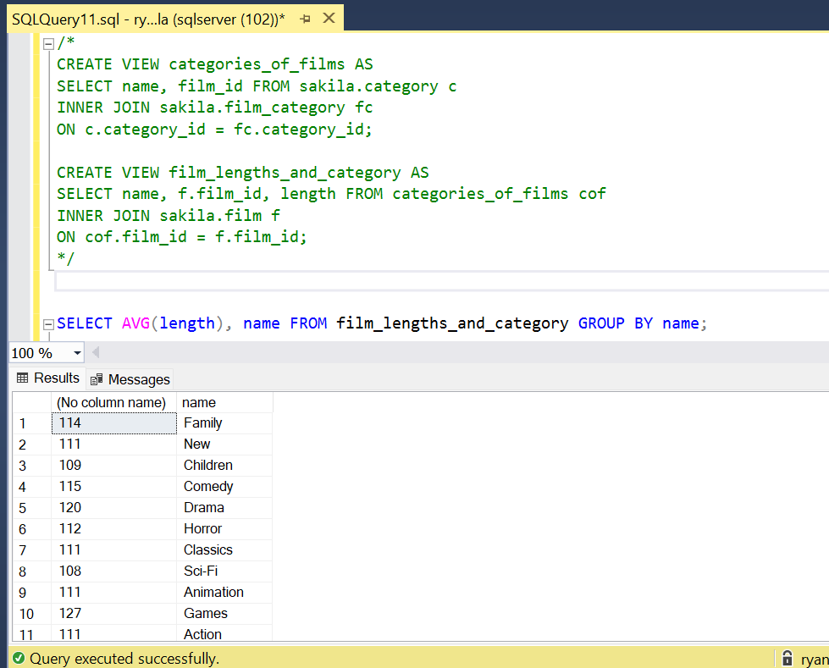

15)How many movies have Robots in them?

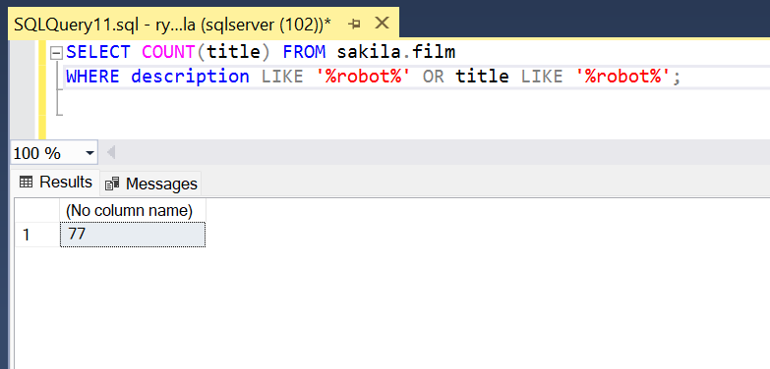

16)Find the movie(s) with the longest runtime.

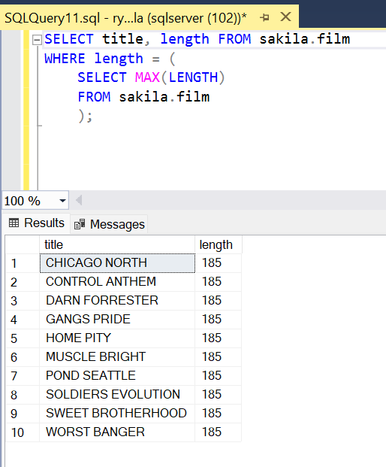

17)Count how many movies were released in 2010.

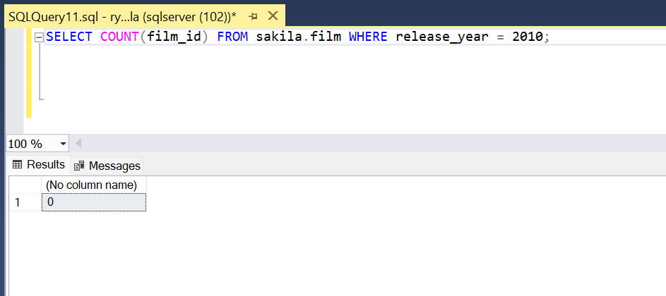

18)Return the full name of the staff member – in a column named full_name – with the ID of 1.

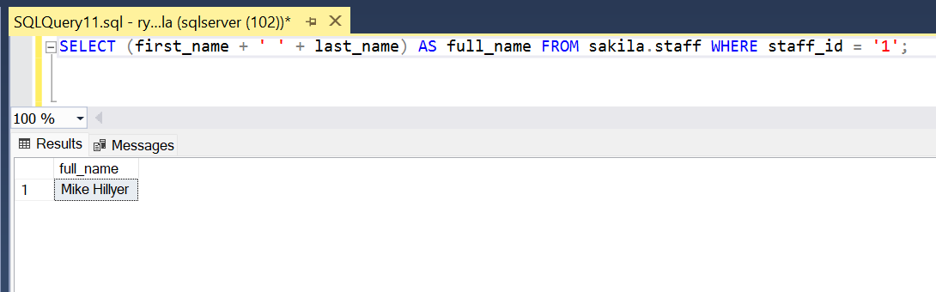

19)Retrieve all movies that Fred Costner has appeared in.

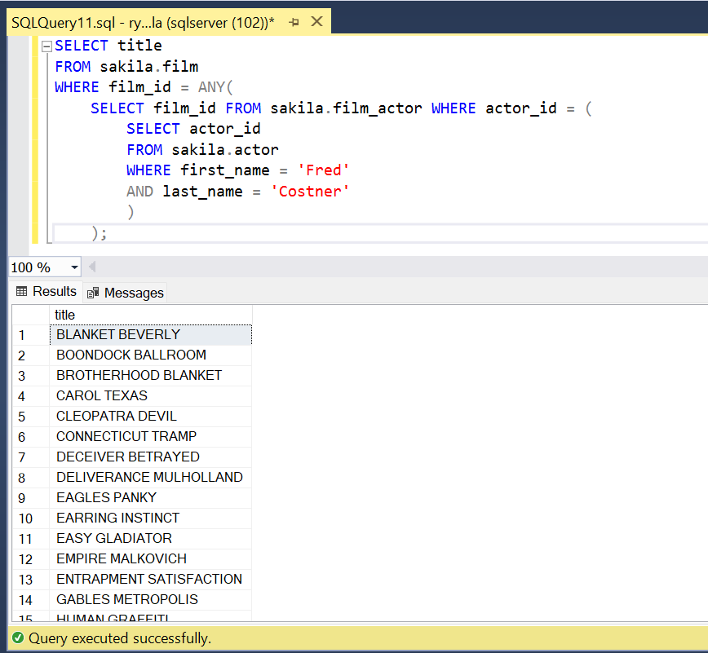

20)Find out which location has the most copies of BUCKET BROTHERHOOD.

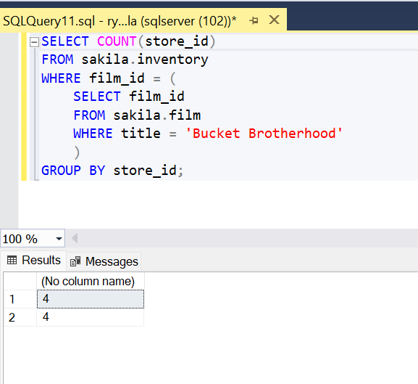

21)How many distinct countries are there?

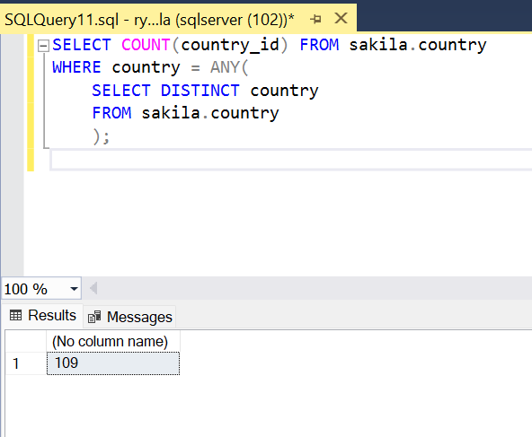

22)What are the names of all the languages in the database (sorted alphabetically)?

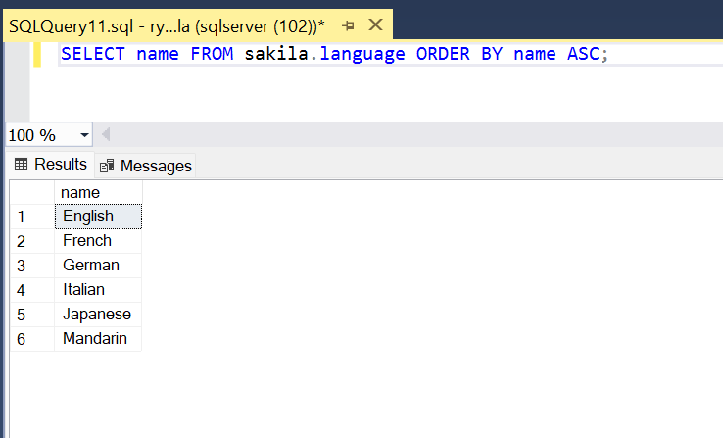

23)Return the full names (first and last) of actors with “son” in their last name, ordered by their first name.

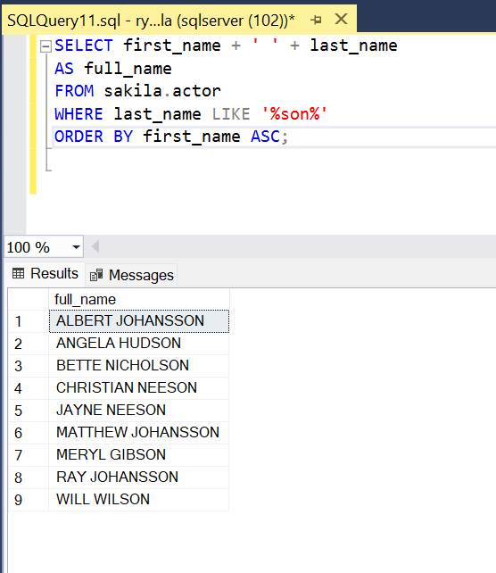

World Database Exercises

Each Exercise should return at least one record, according to its individual specification.

1)Using COUNT, get the number of cities in the USA.

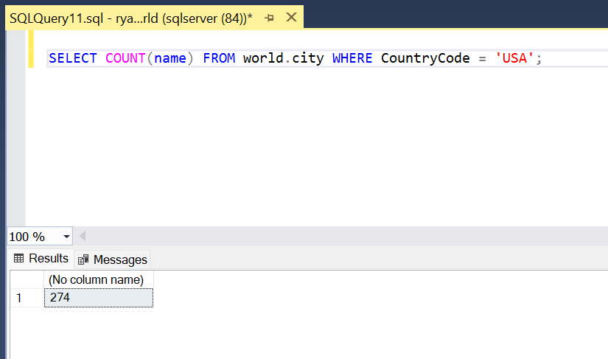

2)Find out what the population and average life expectancy for people in Argentina (ARG) is.

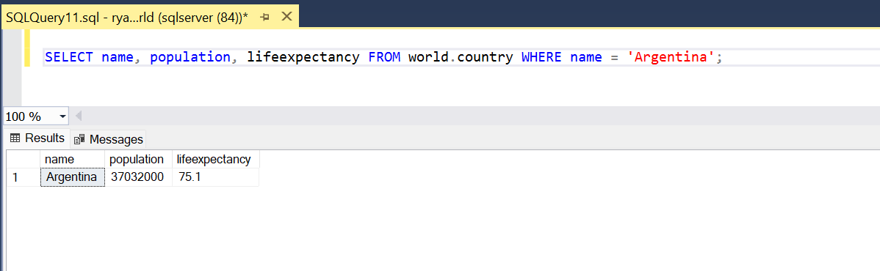

3)Using IS NOT NULL, ORDER BY, LIMIT, what country has the highest life expectancy?

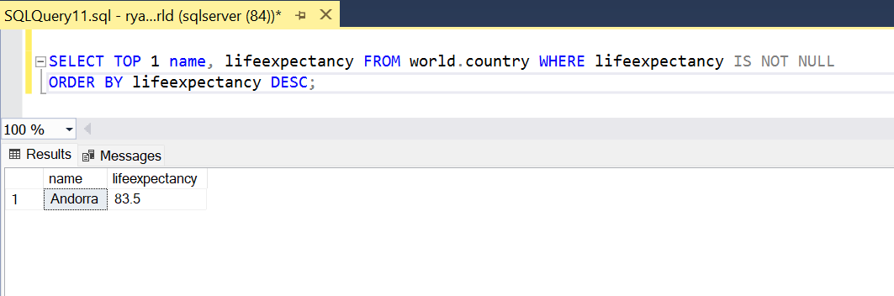

4)Using JOIN … ON, what is the capital of Spain (ESP)?

5)Using JOIN … ON, list all the languages spoken in the 'Southeast Asia' region.

6)Select 25 cities around the world that start with the letter 'F' in a single SQL query.

7)Using COUNT, get the number of cities in China.

8)Using IS NOT NULL, ORDER BY, & LIMIT, what country has the lowest population?

9)Using aggregation, return the number of countries in the database.

10)What are the top ten largest countries by population?

11)List the top five largest cities in Japan.

12)List the names and country codes of every country which has Elizabeth II as its Head of State.

13)List the top ten countries which have the smallest population-to-area ratio.

14)List every unique world language, according to the World database.

15)What are the top 10 richest countries by GDP?

16)What are the top 10 largest countries by surface area?

17)List every country where over 50% of its population can speak French.

18)Which country has the worst life expectancy?

19)What is the most common government form?

20)How many countries have gained independence since records began?